COMSATS UNIVERSITY ISLAMABAD
ATTOCK CAMPUS


MOBILE APPLICATION AND DEVELOPMENT
ASSIGNMENT NO 02
Name | Eman Fatima
Registration Number | FA23-BSE-017
Submitted On | 5th April 2026

SUBMITTED TO
Name | Mr.Muhammed Kamran

1.Set Up Your Development Environment
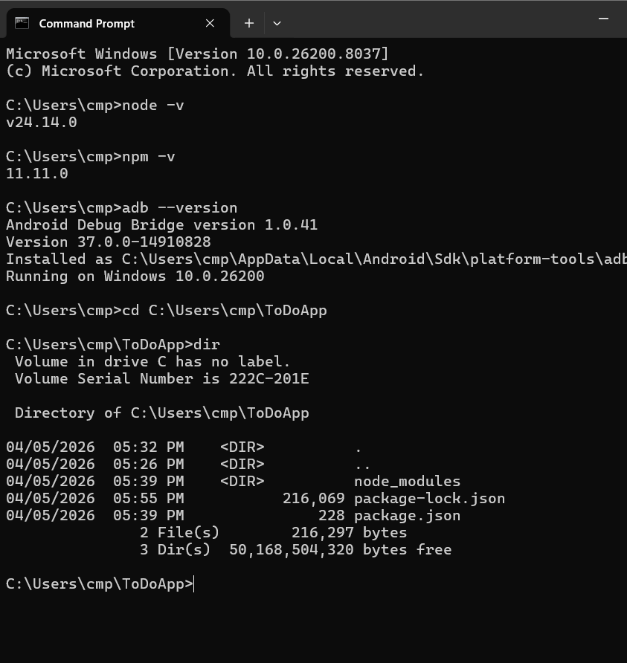
Create a New React Native Project
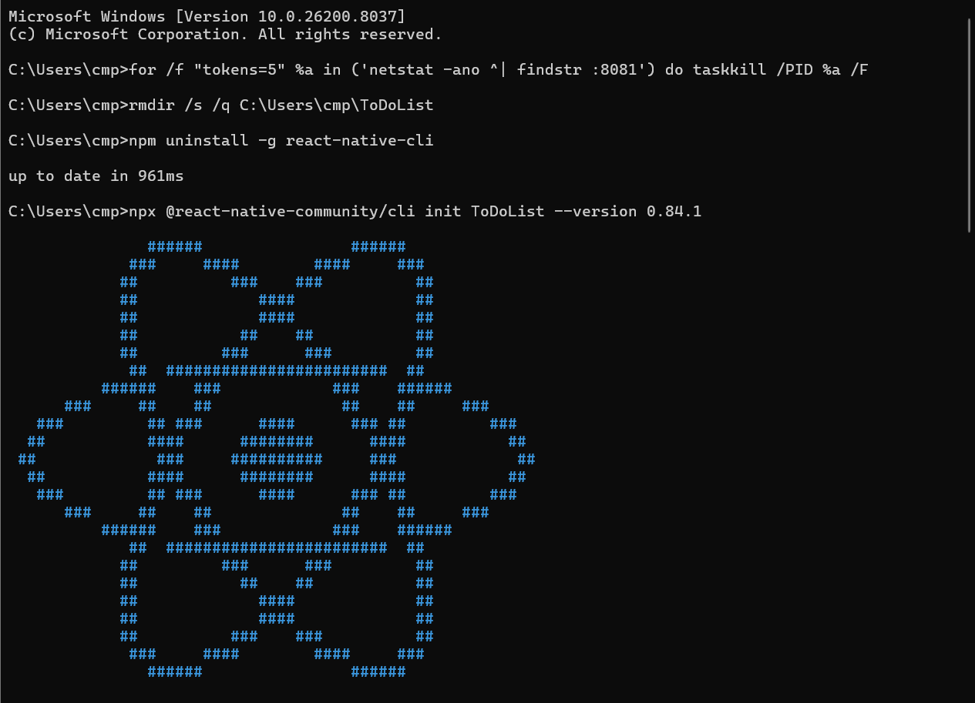
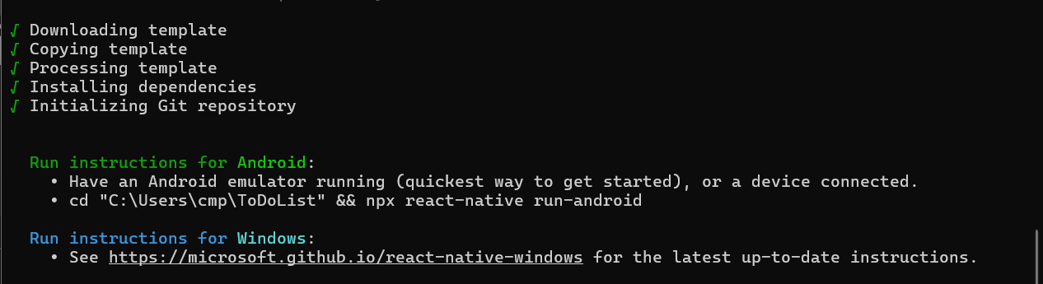
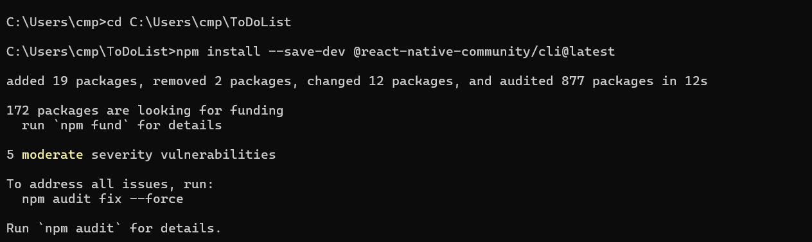
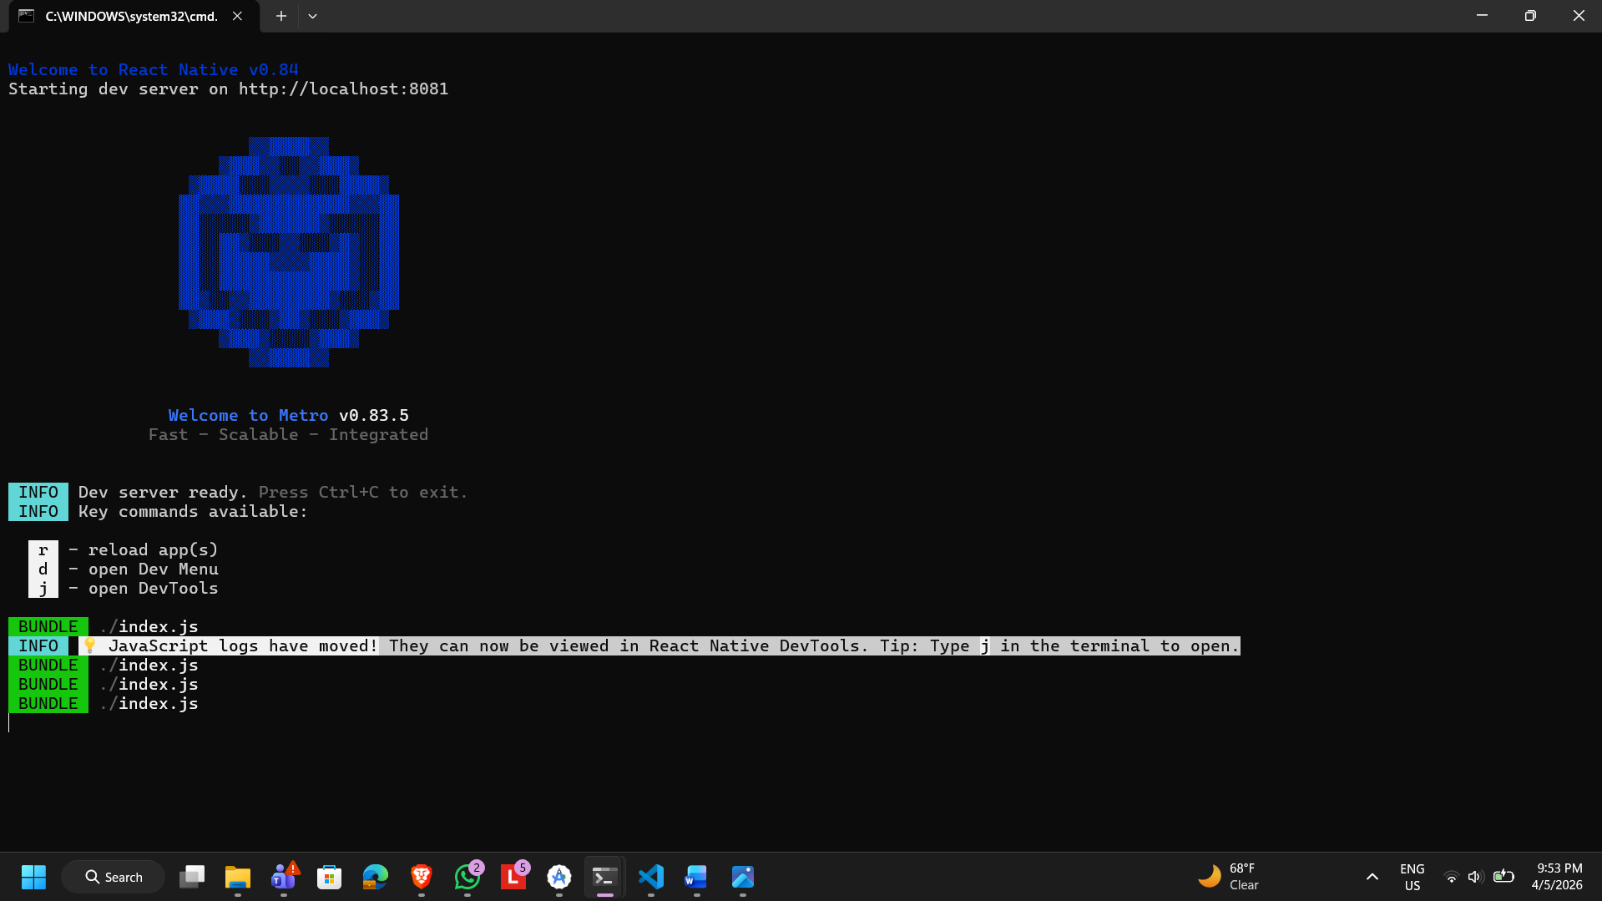

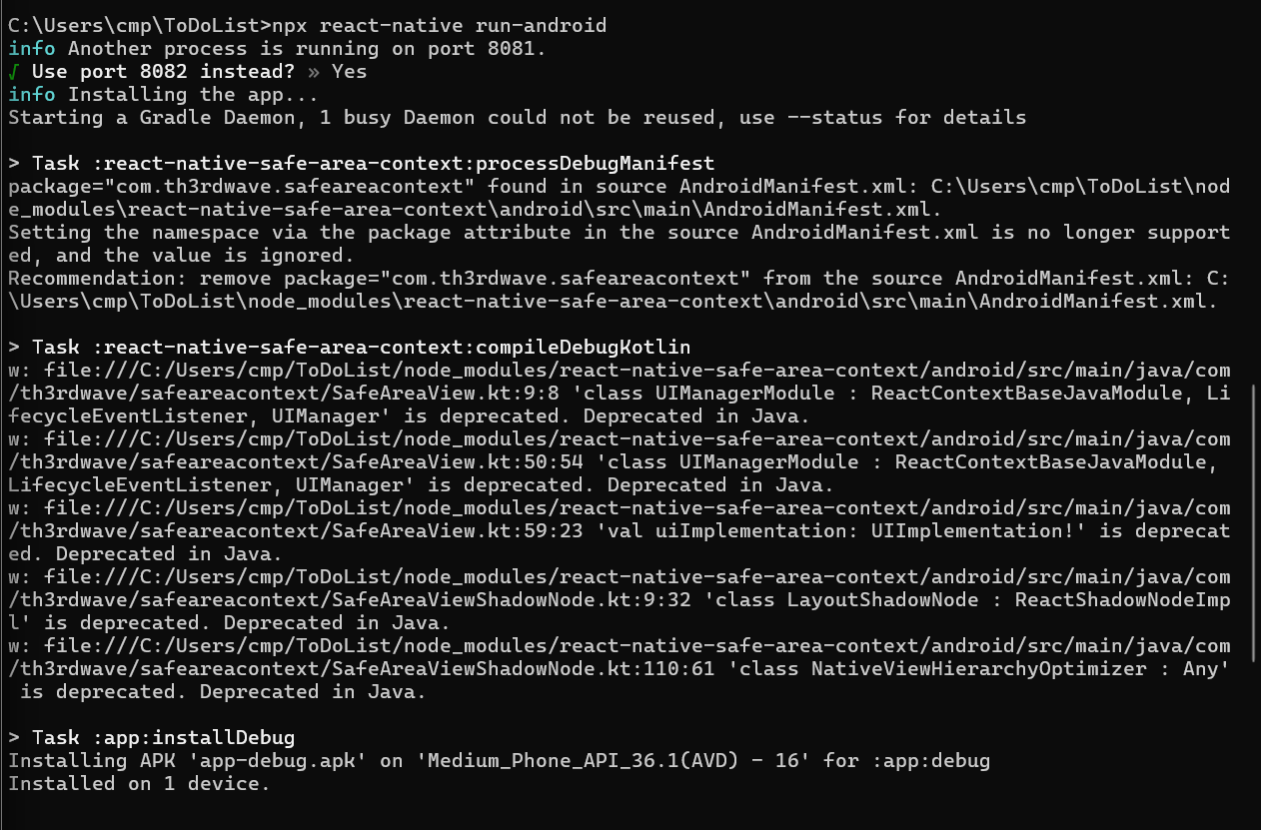
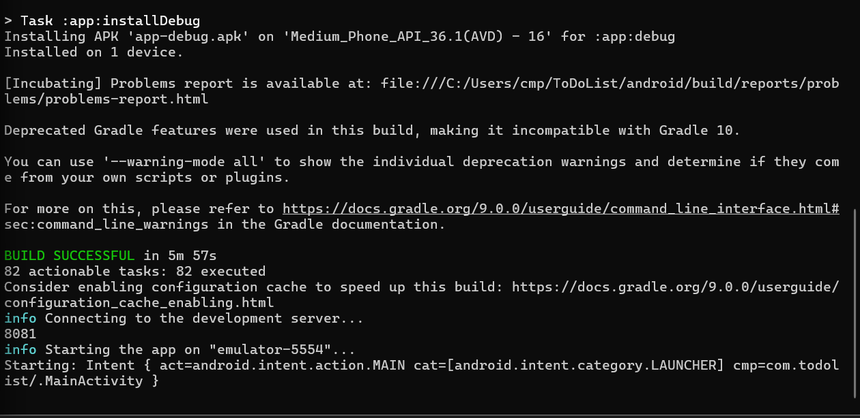

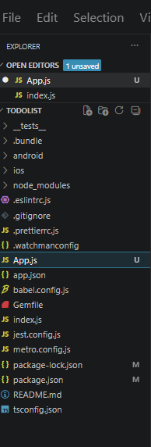
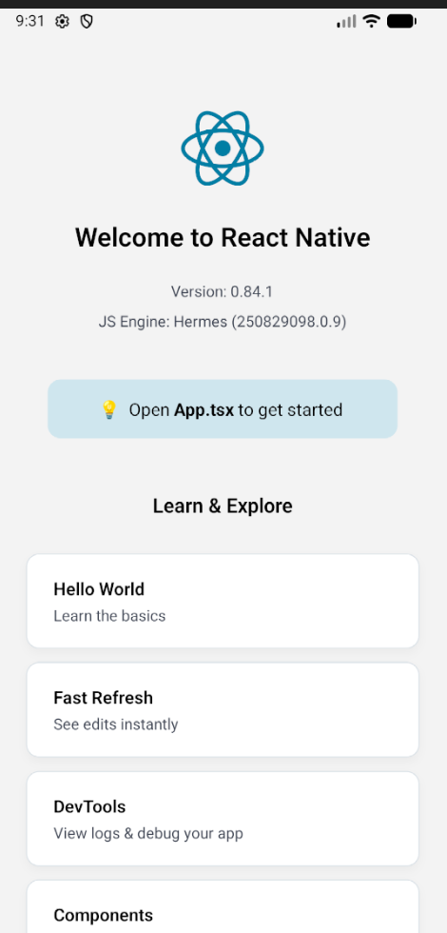
Default React Interface

Modifying Code of App.js

Code for simple ToDoList
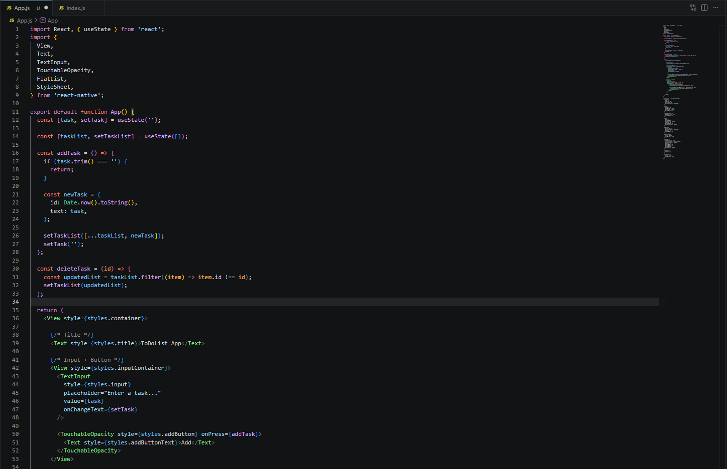
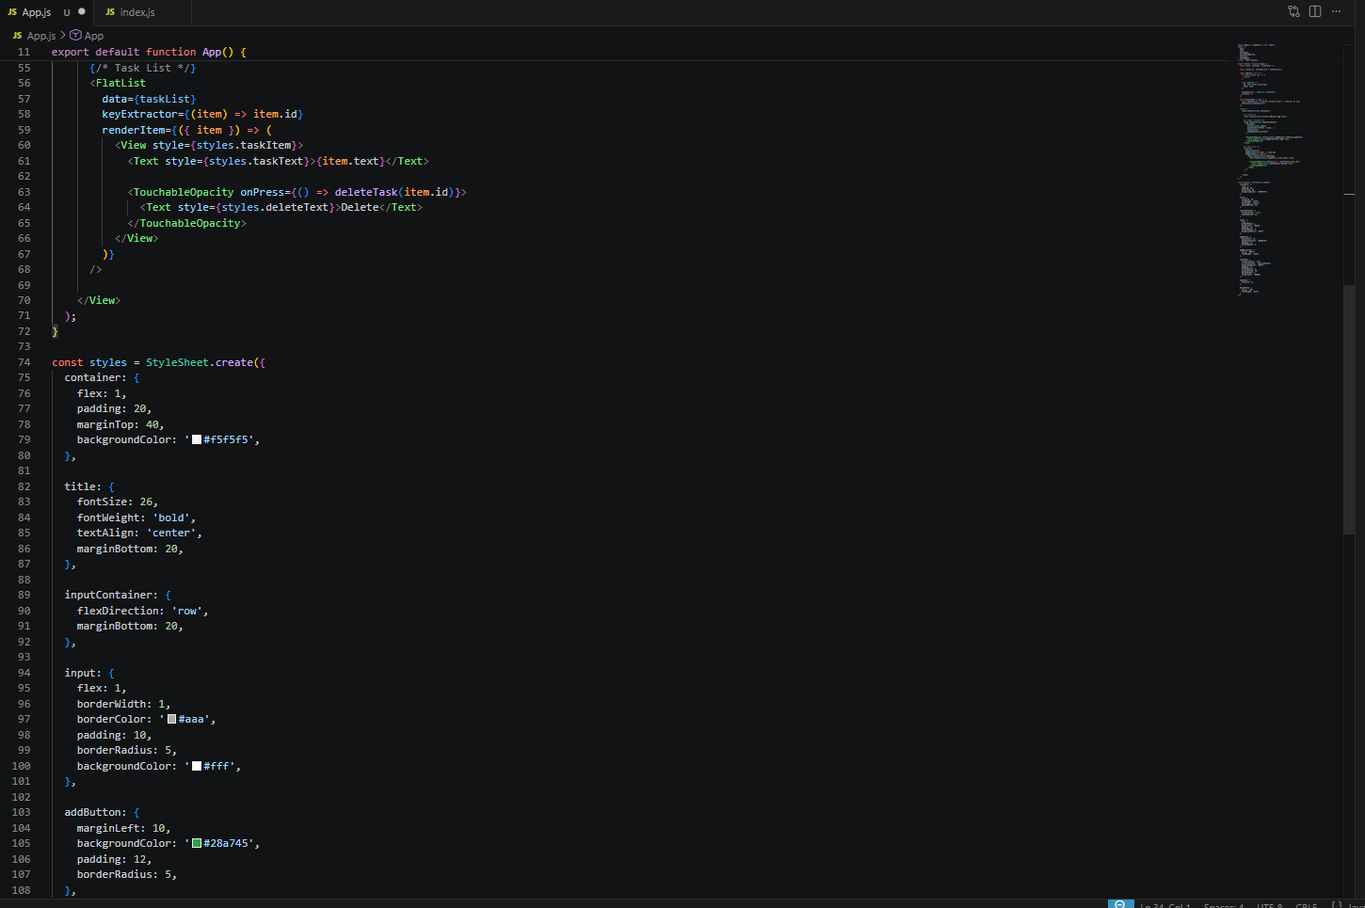
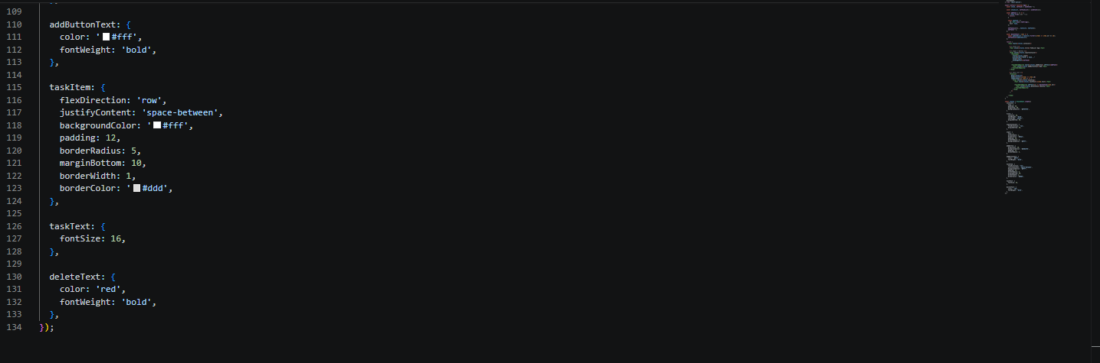
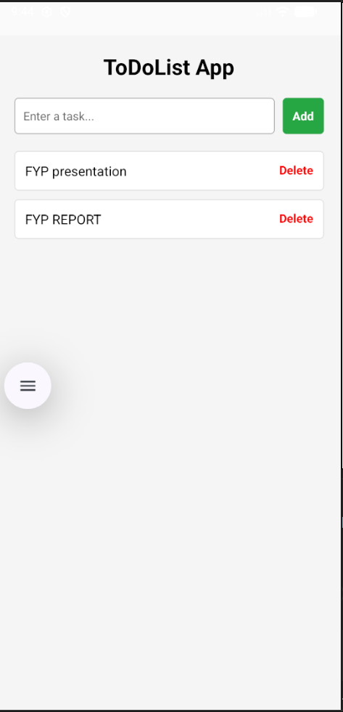
Output on Android Emulator:

